

1

Overdose prevention information for people prescribed opioids for
chronic pain
Enhancing community pharmacists’ capacity
to respond

Isabelle Volpe Suzanne Nielsen Victoria Manning Michael Savic Jarrod McMaugh

June 2020

Contents
Executive Summary 3
- Aims and method 6
- Review of current pharmacist training materials 8
- Consultation with Victorian patients 9
- Consultation with Victorian pharmacists 12
- Developing the materials and obtaining further feedback 18
- Conclusion and next steps 24
Reference list 25
Appendix 1: Review of pharmacist training materials/information/guidelines on overdose prevention (naloxone provision) for people prescribed opioids for chronic pain 26
Appendix 2: Pharmacist poster 32
Appendix 3: Patient leaflet (double-sided) 33
Appendix 4: Pharmacist training animation: illustration example 35

Executive Summary

Background

Current overdose prevention educational materials have been designed as harm reduction approaches for people who use heroin or other illicit opioids. However, pharmaceutical opioids are more likely than heroin to be involved in opioid deaths and opioid hospitalisations in Australia as well as other countries. As such, there is a need to develop educational materials specifically for people prescribed opioids that can be made available through dispensing pharmacies.

Aim

This project was funded by the Department of Health and Human Services (DHHS) to enhance the capacity of pharmacists to provide overdose prevention and naloxone information to people who are prescribed opioids for chronic pain, by developing:

  - Educational materials for pharmacists (a poster and brief training animation)
  - Information materials for patients (a leaflet)

Method

We conducted a review of existing pharmacist training materials, information and guidelines on overdose prevention (naloxone provision) for people prescribed opioids for chronic pain. Following this, we drew on a co-design approach, consulting with patients prescribed opioids for chronic pain (n=14) and pharmacists who dispense opioids for chronic pain (n=9) via qualitative interviews and focus groups. Based on insights from the review and consultation, we developed draft information materials. The draft materials were shared with patients and pharmacists and further refined based on their feedback.

Review of current pharmacist training materials

We identified 25 pharmacist training materials. The five main content areas covered by pharmacist training materials included risk factors for opioid overdose (80%), common signs of opioid overdose (72%), naloxone formulations and administration (64%), having a conversation about overdose prevention/naloxone (72%), and appropriate language (72%). Only 6 of these were from Australia, and only one specifically focused on people prescribed opioids for chronic pain (which was both in an article format and paywalled). The review demonstrated that there is a lack of Australian training materials to help pharmacists engage in conversations about overdose prevention with people prescribed opioids for chronic pain.

Consultation with Victorian patients and pharmacists

A total of 14 patients who are prescribed opioids for chronic pain, and 9 pharmacists participated in focus groups and interviews. Participants held diverse views about the meaning and definition of ‘overdose’, suggesting that that there is not a clear or uniform

understanding of what prescription opioid overdose is among both patients and pharmacists. Most patients were not aware that naloxone could be useful to them, and most pharmacists had never offered naloxone to a chronic pain patient. Pharmacists indicated that discussing overdose with chronic pain patients was considered to be a low priority (compared to addiction potential or other side effects). Although most pharmacists were aware of what naloxone is and how it works, the major barrier to discussing overdose and naloxone was not having the tools and training to do so. However, patients expressed a desire to know about risks, how to avoid them, and how to respond to them.

Developing the materials and obtaining further feedback

Based on the input received from patients and pharmacists, we developed a one-page educational poster for pharmacists and a complimentary two-page leaflet for patients. We also developed a five-minute training animation for pharmacists, to accompany the launch of the materials. Content areas include: why opioid safety is important, how to talk about naloxone, which patients are most at risk, and key counselling points (‘prepare, prevent, respond’).

Rather than including prescriptive information, the pharmacist poster contains conversation prompts to stimulate discussion as a routine part of prescription opioid dispensing. ‘Key counselling points’ and tips for sensitively approaching overdose and naloxone are provided and are designed to optimise flexibility and a tailored discussion depending on the patient, and the relationship between the patient and pharmacist. The key counselling points on this page follow a ‘prepare, prevent, respond’ format, which is mirrored in the patient leaflet and pharmacist training animation.

The patient leaflet is titled ‘maximising opioid safety’, to emphasise naloxone as a strategy for safety, rather than opioids as inherently risky. The second page of the leaflet includes an ‘opioid safety plan’. This is designed to be a quick-reference resource with essential information presented in a clear an appealing way, which patients can keep with their medicines or in a prominent place.

The draft materials were circulated to patients, pharmacists, and the Pharmaceutical Society of Australia Harm Reduction Committee for further feedback prior to finalisation. Feedback received was positive and reiterated that the materials covered desired content areas, was relevant, and was designed in a way that appealed to both patients and pharmacists.

Conclusions and next steps

This project has developed a new set of materials to educate patients and pharmacists on overdose and naloxone for people prescribed opioids for chronic pain, based on a review of existing materials, and with feedback from patients and pharmacists. The materials include most of the features and content areas requested by patients and pharmacists, and reflects the need for comprehensive but concise and engaging materials, which are appropriate for the particular contexts and sensitivities of this patient group.

There could be an opportunity in the future to develop a brief training package to facilitate use of these materials, and to evaluate the impact of these materials on naloxone uptake in patients prescribed opioids for chronic pain. Similarly, inviting further feedback on the materials once pharmacists have had an opportunity to use it in practice would also be useful and could inform future refinements to the materials.

Aims and method

Background

Accidental pharmaceutical opioid overdose deaths have risen by an average of 7% per year from 2001 to 2012 [1], including pharmaceutical opioids prescribed for pain, and pharmaceutical opioids used nonmedically. Pharmaceutical opioids are now responsible for more opioid deaths and poisoning hospitalisations than heroin [1]. Opioid overdose can be prevented through the administration of naloxone, an opioid overdose reversal drug that can be delivered by injection into a muscle or through an intranasal spray. Naloxone in available in Victoria, Australia via prescription from a doctor or through a pharmacist without a prescription. The provision of naloxone may be particularly useful when paired with patient information and education about safe opioid use, overdose and the risks of long-term opioid use.

People who are prescribed opioids for chronic pain have been shown to have relatively low knowledge or different understandings of overdose prevention [2] and may have unique overdose prevention information needs and preferences for how overdose is framed and talked about. Current overdose prevention educational materials have been designed as harm reduction approaches for people who use heroin or other illicit opioids and are unlikely to be appropriate for people who are prescribed opioids for chronic pain due to different contexts of use, different language, and different understanding and knowledge about overdose risk. Despite being an important point of contact, there are few resources and tools to support pharmacists to provide overdose prevention information to these people. As such, there is a need to develop educational materials specifically for people prescribed opioids that can be made available through dispensing pharmacies.

Aim

This project was funded by the Department of Health and Human Services (DHHS) to fill this need. The project aimed to enhance the capacity of pharmacists to provide overdose prevention information to people who are prescribed opioids for chronic pain, by developing:

  - Educational materials for pharmacists (a poster and brief training animation)
  - Information materials for patients (a leaflet)

The research team included researchers from Turning Point and Monash Addiction Research Centre, as well as a practicing community pharmacist from the Pharmaceutical Society of Australia.

Methods

As illustrated in Figure 1, this project involved several activities. We conducted a review of existing pharmacist training materials, information and guidelines (henceforth referred to as ‘training materials’) on overdose prevention (naloxone provision) for people prescribed

opioids for chronic pain. This involved searching academic databases and non-academic (‘grey’) literature for relevant pharmacist training materials on opioid overdose that were published in English. We then tabled relevant information about the characteristics, content covered and format of training materials and calculated the frequencies of common characteristics and elements.

Following this and after obtaining ethics approval from the Monash University Human Research and Ethics Committee (MUHREC project ID 22418), we drew on a co-design approach, consulting with patients prescribed opioids for chronic pain (n=14) and pharmacists who dispense opioids for chronic pain (n=9). To do this, we used qualitative interviews and focus groups. Patients were recruited via social media (e.g. Facebook sponsored posts, Twitter) and promotion through pain management groups. Pharmacists were recruited via social media (e.g. Facebook groups and Twitter), pharmacy networks and our own networks. Advertisements inviting participation in the project asked participants to contact the study team directly, and a member of the study team screened participants for eligibility. Explanatory statements were emailed to participants after an initial phone call to explain study details.

One focus group with patients was held at Turning Point in Richmond and for participant preference, the remaining participants completed individual telephone interviews. Due to COVID-19 restrictions, focus groups with pharmacists (to be held at the Pharmaceutical Society of Australia, Parkville) were replaced with individual telephone interviews. Interviews and focus groups were approximately 1 hour in duration. All participants received $50 gift cards as a token of appreciation.

Interviews and focus groups covered the following topics.

  - Overdose knowledge
  - Naloxone knowledge
  - Desirable features of an intervention and materials
  - Factors influencing naloxone provision (for pharmacists)

Thematic analysis was used to identify common themes in interviews and focus groups.

Based on insights from the review and consultations, we developed draft information materials (a poster for pharmacists, and a leaflet for patients) and its look was designed to be concise, engaging, and appropriate for the audience of pharmacists and patients. We sought feedback from the same patients and pharmacists, as well as the Pharmaceutical Society of Australia Harm Reduction Committee, further refining the materials based on this feedback. This was done via telephone, email and an online feedback form that included open-ended and structured questions.

Figure 1. Flowchart of the study design.
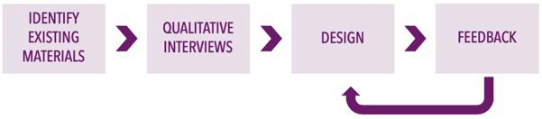

Review of current pharmacist training materials

We identified 25 pharmacist training materials on overdose prevention (including advice for naloxone provision) for people prescribed opioids for chronic pain. As illustrated in Appendix 1, the majority (n=19, 76%) of these were developed overseas. Given the different healthcare systems, prescribing practices, and policies, these were had limited relevance to the Australian context (or Victoria, more specifically). For example, many resources referenced naloxone brands which are not available in Australia, American health systems (e.g. ‘911’ instead of ‘000’, ‘EMS’ instead of ‘ambulance’), and the American opioid ‘public health crisis’.

Formats included written guidelines or factsheets (n=18, 72%), articles (n=2, 8%), information on a website (n=1, 4%), a webinar, video, or podcast (n=2, 8%), or a training package (n=2, 8%). Of the written guidelines or factsheets, the length of materials ranged from 1 to 76 and only half were 2 pages or less (n=9).

The five main content areas covered by pharmacist training materials included risk factors for opioid overdose (80%), common signs of opioid overdose (72%), naloxone formulations and administration (64%), having a conversation about overdose prevention/naloxone (72%), and appropriate language (72%). Only seven tools incorporated all five of these areas, in documents which ranged from 3 – 58 pages. This indicates a need to a develop comprehensive (albeit brief) pharmacist training materials.

Of the six Australian tools, one was developed in Victoria, one in New South Wales, one in South Australia, and the other three were not state- or territory-specific (see Table 1). While these tools were more relevant to the Australian context, only one of those specifically focused on people prescribed opioids for chronic pain, while the others focused on opioid overdose in general. Of the six Australian materials, three were behind a paywall (including the only ‘prescribed opioid’-focused material).

This review demonstrated that there is a lack of free-to-access Australian training materials tailored to the needs of people prescribed opioids for chronic pain.

Table 1. Summary of Australian pharmacist training materials

Material | Format | Access | Pages | Focus | Content areas*
Clinical tips: Naloxone [3] | Article | Paywall | 2 | Prescribed opioids for chronic pain | 1, 3, 5
Recognising and managing opioid overdose in the community: A key role for pharmacists [4] | Article | Paywall | 2 | Non-specific | 1, 2, 3, 4, 5
Guidance for provision of Pharmacist Only medicine [5] | Written guidelines | Paywall | 3 | Non-specific | 1, 2, 3, 4, 5
Opioid overdose response & take home naloxone policy [6] | Written guidelines | Free access | 40 | Non-specific | 1, 2, 3, 4, 5
Talking to patients about naloxone [7] | Factsheet | Free access | 2 | Non-specific | 4, 5
Overdose prevention and response including naloxone:  Brief advice for clients [8] | Written guidelines | Free access | 6 | Non-specific | 1, 2, 3, 4, 5
* Content areas:
- Risk factors for opioid overdose
- Common signs of opioid overdose
- Naloxone formulations and administration
- Having a conversation about overdose prevention/naloxone
- Appropriate (e.g. non-stigmatising) language

Consultation with Victorian patients

Patient characteristics

A total of 14 patients who are prescribed opioids for chronic pain participated in focus groups and interviews. As illustrated in Table 2, there were an equal number of female and male participants, as well as patients located in metropolitan and non-metropolitan Melbourne. On average, participants were 52 years old (range from 29-83 years) and had a range of education backgrounds. Participants had been prescribed opioids for an average of 8.4 years (range from 2-30 years, SD=8.5) and were prescribed a range of opioids: oxycodone (64.3%), tramadol (28.6%), tapentadol (14.3%), codeine (14.3%), buprenorphine (7.1%). Three patients were prescribed more than one opioid. The average highest daily prescribed dose was 106.3mg oral morphine equivalent (range from 7.5-360mg, SD=88.4).

Table 2. Characteristics of patients (n=14)

Variable | Category | Statistic
Gender | Female | 50% (7)
 | Male | 50% (7)
 | Other | 0
Age | Mean | 52.4 (SD=17.6)
 | Range | 29-83 years
Location | Metropolitan Melbourne | 50% (7)
 | Non-metropolitan Melbourne | 50% (7)
Highest level of education | Year 11 or below | 21.4% (3)
 | Year 12 | 28.6% (4)
 | Certificate 3 or 4 | 7.1% (1)
 | Diploma | 21.4% (3)
 | Bachelor degree | 7.1% (1)
 | Graduate Certificate | 7.1% (1)
 | Postgraduate Degree | 7.1% (1)
Length of time prescribed | 0 to 4 years | 35.7% (5)
opioids for chronic pain | 5 to 9 years | 42.9% (6)
 | 10 to 14 years | 7.1% (1)
 | 15 years or more | 14.3% (2)
Type of opioids prescribed* | Oxycodone | 64.3% (9)
 | Tramadol | 28.6% (4)
 | Tapentadol | 14.3% (2)
 | Codeine | 14.3% (2)
 | Buprenorphine | 7.1% (1)
Highest daily prescribed dose | 0-49mg | 21.4% (3)
(oral morphine equivalent) | 50-99mg | 28.6% (4)
 | 100-149mg | 21.4% (3)
 | 150mg+ | 28.6% (4)
*Percentages do not add up to 100%, due to concurrent prescribing

Patient knowledge of overdose

Patients held diverse views about the meaning and causes of ‘overdose’. Participants most commonly thought that overdose refers to ‘taking too much’, especially taking more than the prescribed dose. Another common belief was that overdose was related to illicit substance use (including associations with ‘druggies’ and ‘IV drug users’). Other beliefs included that overdose was strongly related to addiction, with some patients using ‘addiction’ and ‘overdose’ interchangeably. Patients also associated overdose with certain types of people or behaviour, including people who show carelessness, people who ‘like to be out of it’, people without social supports, people with mental health difficulties (including suicidality), and people experiencing financial stressors. Only two patients mentioned mixing opioids with alcohol or other medicines as a cause of overdose.

Patients also expressed different understandings of the signs and symptoms of overdose. The most common signs and symptoms mentioned included those related to drowsiness (including falling asleep, loss of consciousness, being unresponsive, and slowed reactions). Less common signs or symptoms reported included stopped breathing, constipation, foaming at the mouth, convulsions, changes in heartbeat, slurred speech and altered vision. Patients often described scenarios included stigmatised ideas of overdose (including ‘sitting on a lino floor’, being on the street, and illicit drugs), and ‘worst case scenarios’ (‘family finding you’,

hospitalisation, and death). These scenarios illustrate that the term ‘overdose’ holds heavy connotations for patients, which may be loaded with strong emotions.

When asked about how they knew this information about overdose, patients listed a range of information sources. Some patients received information from their doctor or pharmacist, although one participant discussed wanting to learn about opioid risks, but not receiving information from their doctor, and receiving only a medicine printout from their pharmacist. Many participants listed media sources, including news about celebrity overdose deaths and ambulance television shows. Other sources included social media, internet searches, and discussions with friends (who may be health professionals).

Patient knowledge of naloxone

Most (n=12) patients had heard of naloxone, and most (n=9) patients were aware that naloxone was used to reverse the effects of opioids, or stop an overdose. However, it was evident that there was little understanding of the practicalities of naloxone administration, including who can access or administer naloxone. For instance, some patients believed that a qualification was required to administer naloxone, while others thought that naloxone must be administered by paramedics and other health professionals. They were also unsure about how a layperson can access naloxone, and how to administer naloxone. Naloxone was only known amongst participants in its injection form, with no patients expressing awareness of its nasal spray form. As with patient perceptions about overdose, some participants strongly associated naloxone with illicit drug use, including perceptions that it was for heroin or ‘drug users’. Participants also expressed uncertainty around the ‘safety’ of naloxone, including concerns around the effects of naloxone if administered in a situation where an overdose had not occurred.

Desired content areas

Most (n=12) patients expressed that they would like to receive information about overdose in the pharmacy setting, including how naloxone could be useful to them. Patients’ desired content is summarised in Table 3. The most commonly discussed content area was advice on how to prevent an overdose. This was followed by the signs and symptoms of overdose, general information about opioid risks, how to respond to overdose symptoms, how to use naloxone, information about the safety of naloxone, and where and how to obtain naloxone. Less frequently discussed content areas were ‘what is naloxone’, discussing naloxone with family and friends, how to store naloxone, alternative strategies to manage pain and how naloxone works.

Although most patients expressed that they would like to receive information from their pharmacist about overdose and naloxone, a minority did not. These patients expressed that they would prefer to receive a leaflet (while other patients expressed that they did not like reading leaflets). These findings confirm that it is important that pharmacist and patient materials are able to communicate key message in standalone form, as well as complimenting a pharmacist-delivered intervention.

Table 3. Summary of desired content areas discussed by patients

Content 1 2 3 4 5 6 7 8 9 10 11 12 13 14 15 16 n %
Signs/symptoms of overdose |  |  |  |  |  |  |  |  |  |  |  |  |  |  | 50% (8)
Opioid risks |  |  |  |  |  |  |  |  |  |  |  |  |  |  | 43.8% (7)
How to reduce risk of overdose |  |  |  |  |  |  |  |  |  |  |  |  |  |  | 56.3% (9)
Alternative strategies to manage pain |  |  |  |  |  |  |  |  |  |  |  |  |  |  | 12.5% (2)
How to respond to overdose symptoms |  |  |  |  |  |  |  |  |  |  |  |  |  |  | 37.5% (6)
What is naloxone? |  |  |  |  |  |  |  |  |  |  |  |  |  |  | 25% (4)
What is it used for? |  |  |  |  |  |  |  |  |  |  |  |  |  |  | 12.5% (2)
How does it work? |  |  |  |  |  |  |  |  |  |  |  |  |  |  | 6.3% (1)
How to use naloxone |  |  |  |  |  |  |  |  |  |  |  |  |  |  | 37.5% (6)
Where/how can you get naloxone? |  |  |  |  |  |  |  |  |  |  |  |  |  |  | 31.3% (5)
Discussing naloxone with family/friends |  |  |  |  |  |  |  |  |  |  |  |  |  |  | 25% (4)
Storage |  |  |  |  |  |  |  |  |  |  |  |  |  |  | 18.8% (3)
Naloxone safety |  |  |  |  |  |  |  |  |  |  |  |  |  |  | 37.5% (6)
Note: this is a summary of content areas which were raised spontaneously by patients, rather than being prompted by the researcher.
Content areas are colour coded by how common the area was: 0-24% (low): lightest 
25-49% (moderate): medium 
50%+: darkest 

As expected, most patients would prefer to use a nasal spray form of naloxone. The exception was one patient with sinus problems, who would prefer an injection. This speaks to the importance of providing both forms as options.

Consultation with Victorian pharmacists

Pharmacist characteristics

A total of nine pharmacists who dispense prescription opioids participated in telephone interviews. As illustrated in Table 4, the majority of pharmacists were women and were located in metropolitan Melbourne (although approximately 45% were located in non- metropolitan Melbourne). On average, participants were 35 years old (range from 25-52 years), and on average participants had worked as pharmacists for 11 years (range 2-29 years, SD=8.5), although participants spanned the entire spectrum of experience and had a range of education levels (minimum bachelor degree). Most participants were community pharmacists (88.9%), with the exception of one hospital pharmacist (11.1%). There was an even split of pharmacists who did and did not work in pharmacies dispensing medicines for opioid dependence (44.4% each), with one pharmacist working as a locum in both settings (11.1%). Most pharmacists considered their overdose knowledge to be ‘developing’ (88.9%) compared to ‘strong’ (11.1%), and all pharmacists rated their naloxone knowledge as ‘developing’ (100%).

Table 4. Characteristics of pharmacists (n=9)

Variable | Category | Statistic
Gender | Female | 66.7% (6)
 | Male | 33.3% (3)
 | Other | 0
Age | Mean | 34.7 (SD=8.4)
 | Range | 25-52 years
Location | Metropolitan Melbourne | 55.6% (5)
 | Non-metropolitan Melbourne | 44.4% (4)
Highest level of education | Bachelor degree | 44.4% (4)
 | Graduate Certificate/Diploma | 22.2% (2)
 | Postgraduate Degree | 33.3% (3)
Length of time practising as a | 1 to 5 years | 22.2% (2)
pharmacist | 6 to 10 years | 44.4% (4)
 | 11 to 20 years | 11.1% (1)
 | 20 years or more | 44.4% (2)
Type of pharmacy environment | Community | 88.9% (8)
currently worked in | Hospital | 11.1% (1)
Pharmacy provision of medicines | Yes | 44.4% (4)
for opioid dependence | No | 44.4% (4)
 | Varies (locum) | 11.1% (1)
Self-rated overdose knowledge | Strong | 11.1% (1)
 | Developing | 88.9% (8)
Self-rated naloxone knowledge | Strong | 0
 | Developing | 100% (9)

Pharmacist knowledge of overdose

Compared to patients, pharmacist understandings of ‘overdose’ were far less disparate, although there was still variation. ‘Overdose’ was often conceptualised as existing on the more severe end of a spectrum of ‘adverse side effects’; this could be a range of adverse effects (described by one pharmacist as ‘where the adverse effects outweigh the therapeutic benefit’), or adverse effects constituting an ‘emergency’ (i.e. risk of death). Although many pharmacists knew of a range factors that contribute to overdose (such as comorbidities and polypharmacy), overdose was commonly described as the outcome of ‘taking too much’. This way of speaking about overdose may reinforce patient perceptions that overdose only occurs when a patient takes more than the prescribed amount or is careless.

Pharmacists described a range of signs and symptoms of overdose. These include drowsiness, difficulty breathing or respiratory depression, nausea, loss of consciousness, being cold or clammy, vomiting, confusion, dizziness, and difficulties with brain function (especially memory and cognition). One problem highlighted by pharmacists was a difficulty distinguishing (or teaching patients how to distinguish) between these symptoms being undesirable, as compared when they are dangerous and require intervention. For example, one pharmacist discussed that it could be difficult for patients to accurately assess their own respiration rate. It was noted that opioid overdose was not well covered as a standard part of pharmacist training, and therefore that patients may receive different advice relating to overdose, depending on a pharmacist’s self-initiated learning.

Use of the term ‘overdose’ was contentious. Most pharmacists acknowledged the stigma associated with ‘overdose’, with some pharmacists describing ‘overdose’ as having connotations of illicit drug use, nonmedical use or addiction. Others considered it to be an appropriate term to use, as long as it is clearly defined. Pharmacists suggested alternative terms to refer to ‘overdose’, including ‘opioid toxicity’, ‘adverse effects’ ‘adverse reaction’ and ‘severe side effects’. Ultimately, there was no consensus, and each suggested term had its own problems (i.e. being too technical, too vague, or too emotive).

Pharmacist knowledge of overdose risk

We also asked pharmacists about risk factors for overdose, and the types of patients they considered to be at increased risk (see Table 5). Factors included: medicine-related factors (i.e., type of opioid and dose) and behaviours, treatment experiences, co-occurring issues or behaviours, the individual’s knowledge and circumstances, and certain demographic characteristics. The findings from these interviews suggest that there is not a clear or uniform understanding of what overdose is among both patients and pharmacists. However, it is clear from the amount of discussion around terminology, that language used in the context of prescription opioids is critically important and must address preconceptions about the nature of ‘overdose’.

Pharmacist knowledge of naloxone

Although most pharmacists were aware of what naloxone is and how it works, there were lower levels of knowledge regarding the practicalities of naloxone. Most pharmacists worked in pharmacies that did not stock naloxone, and not all pharmacies were aware that it is available over the counter. Although most pharmacists were aware of naloxone as an injection, only half (n=5, 55.6%) knew that naloxone was available as a nasal spray.

Factors influencing the provision of naloxone and overdose prevention information

Very few pharmacists reported discussing naloxone with patients, largely due to the fact that most pharmacists reported that their pharmacies did not stock naloxone. In those pharmacists who had discussed naloxone, it was rare that patients took home naloxone. To better understand the low uptake in both pharmacists and patients, we asked pharmacists about the barriers to providing patients with naloxone.

Priorities

Discussing overdose with chronic pain patients was largely considered to be a low priority, compared to addiction potential or other side effects. A common sentiment was that patients typically retain only a few key points of information, making it important to communicate only the most relevant information. A key target for this intervention would be to increase pharmacists’ perceptions of the importance of overdose prevention and naloxone.

Patient receptiveness

Resistance from patients was often cited as a reason for not discussing naloxone. This included patients who did not want to discuss overdose or naloxone and patients who are perceived to be ‘difficult’ (i.e. exhibiting defensive or confrontational behaviour). Pharmacists also raised that patients were often less receptive to receiving advice from pharmacists than their GPs, especially where there was conflicting advice. Multiple pharmacists expressed that they were often seen as ‘shopkeepers’, while GPs have a ‘counselling’ role. Some pharmacists expressed concern that conflicting advice could cause tension in the relationship between patient-pharmacist-GP, potentially compromising the patient’s treatment.

Sensitivity

A common concern from pharmacists was dealing with the sensitive nature of conversations around overdose and naloxone. Stigma was a common theme throughout the interviews, serving as a major barrier to discussing these topics, as well as concerns about exacerbating a patient’s fear of overdose. This requires pharmacists to ‘break down barriers’ in their conversations with clients, so that patients are receptive to conversations. One pharmacist highlighted that this was more challenging among some demographic groups, including those from cultural backgrounds which may have greater stigma around overdose. Some pharmacists were concerned that patients could feel profiled if approached about naloxone. It is possible that this concern is reinforced by the fact that many pharmacists do actively profile patients when deciding whether to offer naloxone.

Appropriateness for patient

Pharmacists described making decisions about whether it was appropriate or necessary to discuss overdose and naloxone with individual patients. Pharmacists described a variety of factors considered in this decision, including: the patient’s capability to effectively use naloxone, the cost of naloxone (which was perceived to be unaffordable for many), the format of naloxone (injection was considered a major barrier to uptake). However, the most common factor was whether the patient was considered ‘high risk’. As shown in Table 5, risk factors for overdose are not always consistent or accurate between pharmacists. Therefore, providing information on how to identify risk in patients may be useful in guiding pharmacist decisions.

Having the tools to discuss naloxone

Finally, a common concern among pharmacists was low confidence or comfort in their ability to discuss naloxone, particularly in the busy pharmacy environment. Many pharmacists expressed that they would ideally like to discuss overdose and naloxone, but lack of time prohibited long conversations (some pharmacists described often being the sole pharmacist and juggling multiple duties at once). Furthermore, many pharmacists expressed difficulty ‘finding the right words’, while wanting to ensure that patients are well-informed. This supports the need for pharmacists to be confident that they can discuss naloxone in a short conversation, ideally under five minutes.

Desired content areas

In terms of receiving information about overdose and naloxone, pharmacists’ desired content is summarised in Table 6. All pharmacists expressed a desire for information about how to have a conversation about naloxone. Suggestions included giving advice on identifying which patients to discuss naloxone with, using appropriate language, dealing with barriers to discussing naloxone, advice on rapport, and guidance in the form of scripts, checklists, or prompts.

Pharmacists made some further suggestions to encourage pharmacists to discuss naloxone with patients. One suggestion was that materials should focus on making pharmacists feel comfortable dispensing naloxone, rather than teaching them information about the medicine itself. Another strategy to increase the salience (and therefore priority) of naloxone, was to provide facts and statistics to emphasise the need to discuss naloxone, and discuss the benefits to their practice (such as increasing rapport and potentially saving lives). To make the content more engaging, some pharmacists suggested using different formats to provide training (e.g. short, high-quality videos).

Table 5. Risk factors for overdose, as reported by pharmacists

Medicine-related factors  and behaviours | Treatment experiences | Co-occurring issues or  behaviours | Individual knowledge and  circumstance | Demographic  characteristics
Prescribed high dose prescription opioids  Prescribed other medicines (including other opioids, benzodiazepines, antidepressants, antipsychotics, blood pressure medicine)  People taking opioids without a prescription  Changing doses of prescribed opioids | Having multiple prescribers or pharmacists  Not having a good pain management plan  Decreased tolerance after a period of abstinence  First time taking prescribed opioids  Longer term or more complicated treatment with opioids | Alcohol or other drug use  Comorbidities (including mental health, kidney and liver problems, low bone mineral density)  People with history of substance use or substance addiction  Methadone patients | Lack of understanding, or low knowledge of opioids  Living alone  Changed life circumstances (e.g. sustaining a new injury)  Socioeconomic factors (including unemployment, low education level)  People who describe themselves as having an ‘addictive nature’ or identifying as ‘higher risk’ | Elderly people  Young people People living ‘riskier  lifestyles’ (e.g. partying)

17

Table 6. Summary of desired content areas discussed by pharmacists

Content | 1 | 2 | 3 | 4 | 5 | 6 | 7 | 8 | 9 | % (n)
What is overdose? (for patient leaflet) |  |  |  |  |  |  |  |  |  | 22.2% (2)
How can overdose occur? |  |  |  |  |  |  |  |  |  | 33.3% (3)
Signs/symptoms |  |  |  |  |  |  |  |  |  | 44.4% (4)
Risk factors |  |  |  |  |  |  |  |  |  | 44.4% (4)
Reducing risk |  |  |  |  |  |  |  |  |  | 22.2% (2)
How to respond to an overdose |  |  |  |  |  |  |  |  |  | 33.3% (3)
Other pain management strategies |  |  |  |  |  |  |  |  |  | 33.3% (3)
Role for other people (for patient leaflet) |  |  |  |  |  |  |  |  |  | 44.4% (4)
Why is naloxone important? |  |  |  |  |  |  |  |  |  | 22.2% (2)
How does naloxone work? |  |  |  |  |  |  |  |  |  | 33.3% (3)
How to use naloxone |  |  |  |  |  |  |  |  |  | 44.4% (4)
Who can administer? |  |  |  |  |  |  |  |  |  | 11.1% (1)
What to expect after administration |  |  |  |  |  |  |  |  |  | 11.1% (1)
Where/how is naloxone available? |  |  |  |  |  |  |  |  |  | 33.3% (3)
Safety |  |  |  |  |  |  |  |  |  | 22.2% (2)
Storage |  |  |  |  |  |  |  |  |  | 11.1% (1)
How to have a conversation about naloxone |  |  |  |  |  |  |  |  |  | 100% (9)
How to have follow up conversations |  |  |  |  |  |  |  |  |  | 22.2% (2)
Referral pathways |  |  |  |  |  |  |  |  |  | 11.1% (1)
Note: this is a summary of content areas which were raised spontaneously by patients, rather than being prompted by the researcher.

Content areas are colour coded by how common the area was: 0-24% (low): lightest 
25-49% (moderate): medium 
50%+: darkest 

Developing the materials and obtaining further feedback

Developing the materials and obtaining further feedback

Based on the input received from patients and pharmacists, we developed a one-page training poster for pharmacists (see Appendix 2) and a complimentary two-page leaflet for patients (see Appendix 3). In addition to these materials, we developed a five-minute training animation for pharmacists, to accompany the launch of the materials (see Appendix 4). Content areas are detailed in Figure 2.

Rather than including prescriptive and highly structured information, the pharmacist poster contain conversation prompts to stimulate discussion. ‘Key counselling points’ and tips for sensitively approaching overdose and naloxone are provided but allow for flexibility and a tailored discussion depending on the patient (and the relationship between the patient and pharmacist). The pharmacist poster is designed to be displayed where prescribed opioids are stored, prompting conversation about naloxone as a routine part of dispensing. The key counselling points on this page follow a ‘prepare, prevent, respond’ format, which is mirrored in the patient leaflet and pharmacist training animation.

The patient leaflet is titled ‘maximising opioid safety’, to emphasise naloxone as a strategy for safety, rather than opioids as risky. This reflected patient comments about wanting to receive empowering information, rather than messages based on fear which might inadvertently lead to sub-optimal dosing or the ceasing of medication use. The first page includes a rationale for the importance of keeping naloxone in the home. We included common opioid brand names, to help remind patients understand which of their medicines naloxone is relevant to. Although we considered providing information about accessing naloxone via the PBS to address concerns about affordability, we decided to exclude this information to increase the longevity of the materials (so that they would not quickly become outdated). The second page of the leaflet includes an ‘opioid safety plan’. This is designed to be a quick-reference resource with essential information presented in a clear an appealing way, which patients can keep with their medicine or in a prominent place. The plan includes advice to discuss the safety plan with family members, friends, or a carer (serving as a prompt to help patients start a conversation about overdose and naloxone).

As is illustrated in Figure 2, the patient leaflet covers all the main content areas that patients considered important. As the patient and pharmacist materials are designed to be complimentary, most of this information is not duplicated on the pharmacist poster. Additional content areas covered in the pharmacist poster are illustrated in Figure 3. Three content areas (suggested by pharmacists) were excluded from the patient and pharmacist materials for brevity: ‘other pain management strategies’, ‘how to have follow up conversations’, and ‘referral pathways’. This was due to there being extensive materials on pain management and related issues already developed and freely available [9].

The draft materials were circulated to patients, pharmacists, and the Pharmaceutical Society of Australia Harm Reduction Committee for further feedback prior to finalisation.

Figure 2. Patient leaflet content areas

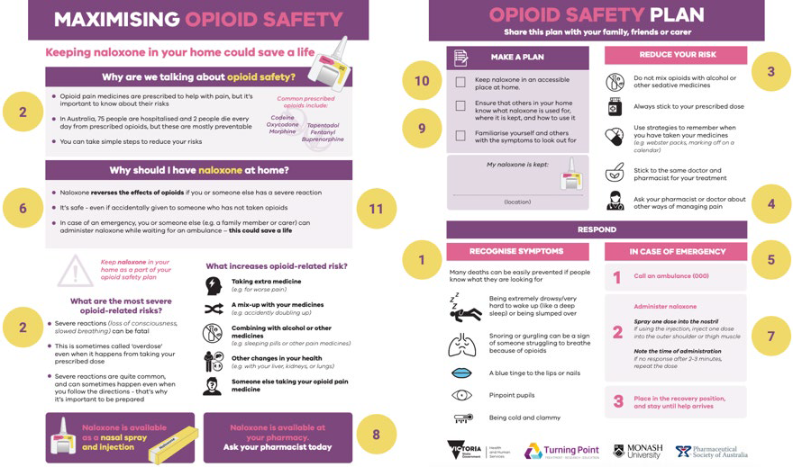
- Signs/symptoms of overdose
- Opioid risks
- Reducing risk of overdose
- Alternative pain management strategies
- Responding to overdose symptoms
- What is naloxone? What is it used for? How does it work?
- How to use naloxone
- Where/how to get naloxone
- Discussing naloxone with family or friends
- Storage
- Naloxone safety

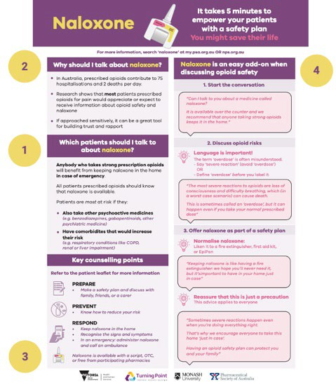
Figure 3. Pharmacist poster content areas

- Risk factors
- Why is naloxone important?
- Where and how is naloxone available?
- How to have a conversation about naloxone

Patient feedback

Patient feedback received was overwhelmingly positive (see Figure 4) and reiterated that the materials were interesting, easy to understand, useful and relevant, and designed in a way that appealed to patients (see Table 7).

Figure 4. Anonymous quotes from patient feedback
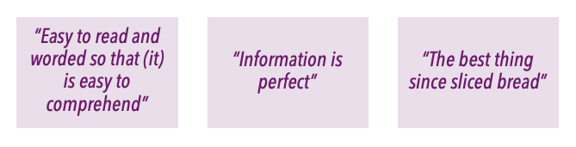

Table 7. Patient feedback (n=6)

 | Strongly agree | Agree | Neither agree nor disagree | Somewhat disagree | Strongly disagree
The topic of this leaflet is interesting to me | 100% | 0% | 0% | 0% | 0%
If this leaflet was given to me at a pharmacy, I would read it | 50% | 16.67% | 33.33% | 0% | 0%
It is easy to understand the words and information in this leaflet | 100% | 0% | 0% | 0% | 0%
I like the design of this leaflet | 100% | 0% | 0% | 0% | 0%
The information in this leaflet is useful and relevant to me | 100% | 0% | 0% | 0% | 0%

Feedback included that the design and eye-catching colours of the leaflet was a major strength. Having a well-designed engaging, informative yet succinct leaflet was described as being crucial for catching the attention of people who experience ‘information fatigue’. One participant noted that for patients who do not live with family, it would be useful to discuss how they can set up a safety plan. We incorporated this into the final leaflet, by expanding on potential supports and using more inclusive language.

One participant treated the leaflet with some scepticism, although they considered it to be ‘well-balanced’ overall. This scepticism was expressed as a comment that the leaflet could be a ‘good marketing ploy for naloxone’. This reflected some experiences we had during the recruitment phase, in which people responded to our study advertisements with cynicism about the purpose of the study, specifically expressing concern about government initiatives to reduce prescription opioid supply. We were mindful of these concerns when designing the leaflets, and included statements which affirmed the value of opioids in pain management. To reinforce that the leaflets were not promoting one particular product, we added an image of a naloxone injection kit (as well as the nasal spray).

Pharmacist feedback

Pharmacist feedback received was positive (see Figure 5) and reiterated that the poster was useful, easy to understand, and designed in a way that appealed to pharmacists (see Table 8). Most importantly, all pharmacists ‘strongly agreed’ that they would be more likely to discuss naloxone with a patient after reading the poster. Pharmacists also provided positive feedback on the patient leaflets.

While the original poster referred to ‘strong opioids’, one pharmacist questioned whether this assumed knowledge of what dose was ‘strong’. We incorporated this feedback by qualifying this statement was an oral morphine equivalent dose.

Figure 4. Anonymous quotes from pharmacist feedback
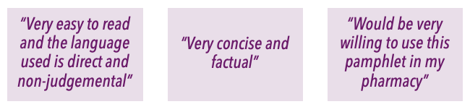

Table 7. Pharmacist feedback (n=4)

 | Strongly agree | Agree | Neither agree nor disagree | Somewhat disagree | Strongly disagree
If this poster was displayed at my workplace, I would read/refer to it | 100% | 0% | 0% | 0% | 0%
This poster is easy to understand | 100% | 0% | 0% | 0% | 0%
I like the design of this poster | 100% | 0% | 0% | 0% | 0%
This poster provides enough information for me to feel confident discussing naloxone | 75% | 0% | 25% | 0% | 0%
I would be more likely to discuss naloxone with a patient after reading this poster | 100% | 0% | 0% | 0% | 0%

One pharmacist suggested the use of the word ‘opioid toxicity’ instead of ‘overdose’. This prompted us to revisit our discussion on ‘terminology’. In the training animation script, rather than advise pharmacists to use ‘severe reaction’ as an alternative to ‘overdose’, we instead listed a range of alternatives, and advise pharmacists to use a word that works for them and their patient.

Conclusion and next steps

This project has developed a new set of materials to educate patients and pharmacists on overdose and naloxone for people prescribed opioids for chronic pain, based on a review of existing materials, and drawing on a co-design approach with patients and pharmacists. The diverse range of experience among patients and pharmacists who took part in these interviews enhances the strength of the interview findings.

The materials include the features and content areas requested by patients and pharmacists, and reflects the need for comprehensive but concise and engaging materials, which are appropriate for the particular contexts and sensitivities of patients who are prescribed opioids for chronic pain. These materials will be launched alongside a brief training animation in a communications campaign. Methods of information dissemination will include: an Australian Journal of Pharmacy podcast, Turning Point and Monash University social media and websites, and Pharmaceutical Society of Australia dissemination channels.

There could be an opportunity in the future to develop a brief training package to facilitate use of these materials, and to evaluate the impact of these materials on naloxone uptake in patients prescribed opioids for chronic pain. Similarly, inviting further feedback on the materials once pharmacists have had an opportunity to use it in practice would also be useful and could inform future refinements to the materials

Reference list

  - Australian Institute of Health and Welfare. Opioid harm in Australia: and comparisons between Australia and Canada. 2018. Available from: https://www.aihw.gov.au/reports/illicit-use-of-drugs/opioid-harm-in- australia/contents/table-of-contents

  - Nielsen S., Peacock A., Lintzeris N., Bruno R., Larance B., Degenhardt L. Knowledge of opioid overdose and attitudes to supply of take-home naloxone among people with chronic noncancer pain prescribed opioids. Pain Medicine. 2018 Mar 1;19(3):533-40.

  - McMaugh, C. Clinical tips: naloxone [Internet]. Australian Journal of Pharmacy. 2019. Available from: https://ajp.com.au/columns/clinical-tips/clinical-tips-naloxone/

  - Johnson J. Advancing your practice: Recognising and managing opioid overdose in the community: A key role for pharmacists. AJP: The Australian Journal of Pharmacy. 2019 Jul;100(1185):62.

  - Pharmaceutical Society of Australia. Guidance for provision of Pharmacist Only Medicine. 2017. Available from: https://my.psa.org.au/s/article/Naloxone-S3- guidance-document

  - NSW Health. Opioid Overdose Response & Take Home Naloxone Policy. 2019. Available from: https://www1.health.nsw.gov.au/pds/ActivePDSDocuments/PD2019_036.pdf

  - Penington Institute. Fact Sheet: Talking to patients about naloxone. [Internet] 2010. Available from: http://www.penington.org.au/wp- content/uploads/2019/08/TalkingToPatientsAboutNaloxone.pdf

  - SA Health. Overdose prevention and response including naloxone: Brief advice for clients. 2019. Available from: https://www.sahealth.sa.gov.au/wps/wcm/connect/45c8c7004cb4faf4965c9eb8c79 1be56/Naloxone+-+Brief+advice+-
+Guide+for+workers+revised+10+January+2019+FINAL+approved.pdf?MOD=AJPERE S&amp;CACHEID=ROOTWORKSPACE-45c8c7004cb4faf4965c9eb8c791be56-
mN5HmHz

  - NPS Medicinewise. Opioids, chronic pain and the bigger picture. 2020. Available from: https://www.nps.org.au/professionals/opioids-chronic-pain

.

Appendix 1: Review of pharmacist training materials/information/guidelines on overdose prevention (naloxone provision) for people prescribed opioids for chronic pain

Title | Author/ Organisation | Date published (if available) | State, Country | Link | Date retrieved | Pages | Format  - Written guidelines  - Article 3.  Information on a website  - Webinar, video, podcast  - Training package | Focus  - People prescribed opioids for chronic pain.  - People who use heroin or  opioid substitution therapy (e.g. methadone, buprenorphine, suboxone etc.)  - Non-specific | Content areas  - Risk factors for opioid  overdose  - Common signs of opioid overdose  - Naloxone formulations & administration  - Having a conversation about  overdose prevention/naloxone  - Appropriate (e.g. non-stigmatising)  language
1. Clinical tips: Naloxone | Carlene McMaugh (AJP) | 26/07/19 | Australia | https://ajp.com.au/columns/c linical-tips/clinical-tips- naloxone/ | 06/08/19 | 2 | 2 | 1 | 1, 3, 5
2. Recognising and managing opioid overdose in the community: A key role for pharmacists | Jacinta Johnson (AJP) | 26/06/19 | Australia | https://search-informit-com- au.ezproxy.lib.monash.edu.au  /documentSummary;res=IELH EA;dn=469687011322034 | 15/08/19 | 5 | 2 | 1, 2 | 1, 2, 3, 4, 5
3. Guidance for provision of Pharmacist Only | Pharmaceutical Society of Australia | June 2017 | Australia | https://my.psa.org.au/s/articl e/Naloxone-S3-guidance- document | 15/08/19 | 3 | 1 | 3 | 1, 2, 3, 4, 5

medicine Naloxone
4. Opioid overdose response & take home naloxone policy | NSW Government | July 2019 | NSW,  Australia | https://www1.health.nsw.gov  .au/pds/ActivePDSDocuments  /PD2019_036.pdf | 23/08/19 | 40 | 1 | 3 | 1, 2, 3, 4, 5
5. Talking to patients about naloxone | Penington Institute | 2019 | VIC,  Australia | http://www.penington.org.au  /wp- content/uploads/2019/08/Tal kingToPatientsAboutNaloxone  .pdf | 23/08/19 | 2 | 1 (factsheet) | 3 | 4, 5
6. Starting the conversation about naloxone | Missouri Opioid State Targeted Response | n.d. | Missouri, USA | https://static1.squarespace.co m/static/594939ba197aea24a 334ef60/t/59f9f0a69140b72b 3a923289/1509552294799/St  arting+the+Conversation+Abo ut+Naloxone.pdf | 23/08/19 | 1 | 1 (factsheet) | 3 | 4, 5
7. Pharmacists and naloxone: Let’s talk about it! | Indiana State Department of Health | n.d. | Indiana, USA | https://www.in.gov/isdh/files  /75_Pharmacists%20and%20 Naloxone.pdf | 23/08/19 | 1 | 1 (factsheet) | 3 | 4, 5
8. Pharmacist Clinical Tool for Initiating Naloxone Discussions | Ontario Pharmacist Association | n.d. | Ontario, Canada | https://www.opatoday.com/ Media/Default/Tools%20and  %20Forms%20-  %20Naloxone/Naloxone- Clinical-Tools.pdf | 27/08/19 | 3 | 1 | 3 | 1, 4, 5
9. Guide for  pharmacists dispensing naloxone to patients | Prevent-Protect | n.d. | USA | https://prescribetoprevent.or g/wp2015/wp- content/uploads/training_too l_translations_english.pdf | 27/08/19 | 2 | 1 | 3 | 1, 3, 4, 5

10. Let’s talk about naloxone — it saves lives | Pain, Palliative Care, and Addiction Special Interest Group in the APhA Academy of Pharmacy Practice & Management | n.d. | USA | https://www.pharmacist.com  /sites/default/files/audience/ LetsTalkAboutNaloxone.pdf | 27/08/19 | 2 | 1 (factsheet) | 3 | 1, 4, 5
11. Pharmacist’s checklist for naloxone training | Centre for Addiction and Mental Health | n.d. | Ontario, Canada | https://www.porticonetwork. ca/documents/204049/0/Pha rmacist_Naloxonechecklist_a mp.pdf/6d08eefc-a1c5-4723- ac49-ea11fe6ee6a9 | 27/08/19 | 1 | 1 | 3 | 2, 3
12. Overdose  prevention and response including naloxone:  Brief advice for clients | SA Health | n.d. | South Australia | https://www.sahealth.sa.gov. au/wps/wcm/connect/45c8c7 004cb4faf4965c9eb8c791be5 6/Naloxone+-+Brief+advice+-  +Guide+for+workers+revised+ 10+January+2019+FINAL+appr oved.pdf?MOD=AJPERES&CA CHEID=ROOTWORKSPACE-  45c8c7004cb4faf4965c9eb8c7 91be56-mN5HmHz | 27/08/19 | 6 | 1 | 3 | 1, 2, 3, 4, 5
13. Narcan Nasal Spray: The Role of the Pharmacist | The Pharmacy Times | 2019 | USA | https://www.pharmacytimes. com/perfect- consult/opioidoverdose/narca n-training-1 | 27/08/19 | n/a | 4 | 3 | 1, 2, 3, 4, 5
14. Guide to  Developing and Managing Overdose | Harm Reduction Coalition | 2012 | New York, USA | http://www.naloxoneinfo.org  /sites/default/files/Start%20a  %20program_Harm%20Reduc tion%20Coalition%2527s%20 | 28/08/19 | 76 | 1 (manual) | 3 | 1, 2, 3

Prevention  and Take-Home Naloxone Projects |  |  |  | Guide%20to%20Developing% 20and%20Managing%20Over dose%20Prevention%20and% 20Take- Home%20Naloxone%20Projec ts_0.pdf
15. Pharmacist Naloxone Dispensing Guide | Chris Trujillo, New Mexico Dept of Health | 2018 | New Mexico, USA | https://nmhealth.org/publicat ion/view/guide/2128/  https://nmhealth.org/publicat ion/view/guide/2127/ | 28/08/19 | 2 (+ 2  page user guide) | 1 | 3 | 1, 2, 3
16. Naloxone Kits Pharmacy | Ontario Pharmacists Association | n.d. | Ontario, Canada | https://www.opatoday.com/ Media/Default/Tools%20and  %20Forms%20-  %20Naloxone/Naloxone%20Ki t%20Pharmacy%20Advertising  .pdf | 28/08/19 | 6 | 1 (+  advertising materials) | 3 | 1, 2, 4, 5
17. Opioid Overdose and Naloxone Reversal | Red Lake Indian Health Service | 2017 | USA | https://academic.oup.com/aj hp/article/74/6/363/5102741  https://www.youtube.com/w atch?v=KcjF9Iw0iuw&feature  =youtu.be | 28/08/19 | n/a | 5 | 1, 2 | 1, 2, 3
18. Opioid Safety | Alliant Health | 2019 | Atlanta, USA | https://www.alliantquality.or g/?q=content/opioid-safety | 28/08/19 | n/a | 5 | 3 | 1, 4, 5
19. Pharmacist prescribing of naloxone | Oregon Government | n.d. | Oregon, USA | https://www.oregon.gov/oha  /PH/PREVENTIONWELLNESS/S UBSTANCEUSE/OPIOIDS/Docu  ments/toolkit/RPh-info- sheet.pdf | 28/08/19 | 2 | 1 (factsheet) | 3 | 1, 4, 5

20. Naloxone access: A Practical Guideline for Pharmacists | College of Psychiatric and Neurologic Pharmacists | n.d. | USA | http://prescribetoprevent.org  /wp2015/wp- content/uploads/naloxone- access.pdf | 28/08/19 | 6 | 1 | 3 | 1, 2, 3
21. Naloxone: A critical tool to fight the opioid crisis | University of Minnesota, College of Pharmacy | 2018 | USA | Slides: https://www.pharmacy.umn. edu/sites/pharmacy.umn.edu  /files/naloxone_-  _a_critical_tool_to_fight_the_ opioid_crisis.pdf  Presentation: https://www.pharmacy.umn. edu/degrees-and- programs/continuing- pharmacy- education/continuing- education-courses/naloxone | 29/08/19 | Slides: 58 | 4 | 1 | 1, 2, 3, 4, 5
22. Opioid safety: Focus on furnishing naloxone | Talia Puzantian and James J. Gasper | n.d. | Californi a, USA | https://prescribetoprevent.or g/wp2015/wp- content/uploads/OpioidSafety FocusOnNaloxone_Pharmacis ts_AUG.18_final-with- links.pdf | 29/08/19 | 36 | 1 | 3 | 1, 2, 3, 4
23. Conversation Starters for Offering Naloxone | Robin Curtis | n.d. | Michigan  , USA | http://www.michiganpharma cists.org/Portals/0/resources/ Community%20Pharmacy/nal oxoneconversationstarts.pdf? ver=2017-05-16-152750-370 | 06/09/19 | 1 | 1 | 1 | 4, 5

24. Managing pain safely, Naloxone toolkit | Partnership Health Plan California | n.d. | Californi a, USA | http://www.partnershiphp.or g/Providers/HealthServices/D ocuments/Managing%20Pain  %20Safely/Naloxone%20Kit_F inal.pdf | 09/09/19 | 42 | 1 | 3 | 1, 2, 3, 4, 5
25. Pharmacists as Champions for Opioid Overdose Prevention and Naloxone Counseling | Jeffrey Fundin & Abigail Brooks | 2014 | USA | https://www.pharmacytimes. com/contributor/jeffrey- fudin/2014/10/pharmacists- as-champions-for-opioid- overdose-prevention-and- naloxone-counseling | 10/09/19 | n/a | 3 | 1 | 1, 2, 3

Appendix 2: Pharmacist poster
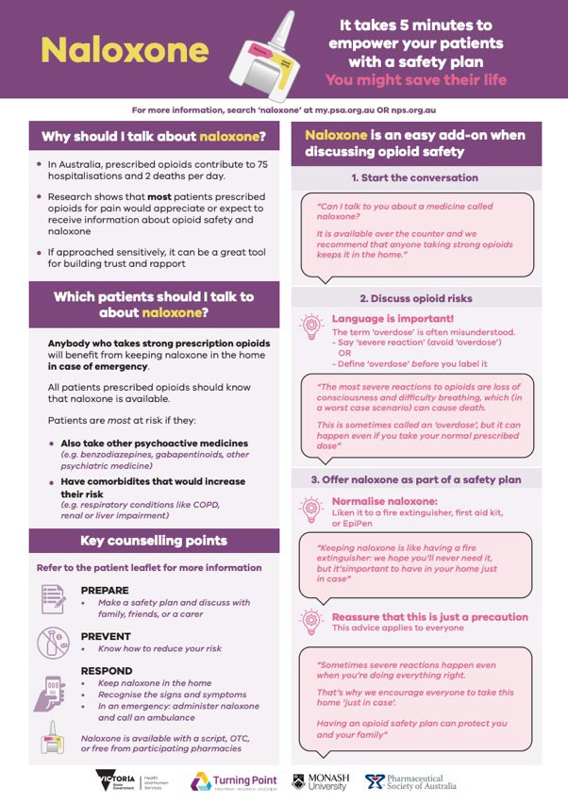

Appendix 3: Patient leaflet (double-sided)
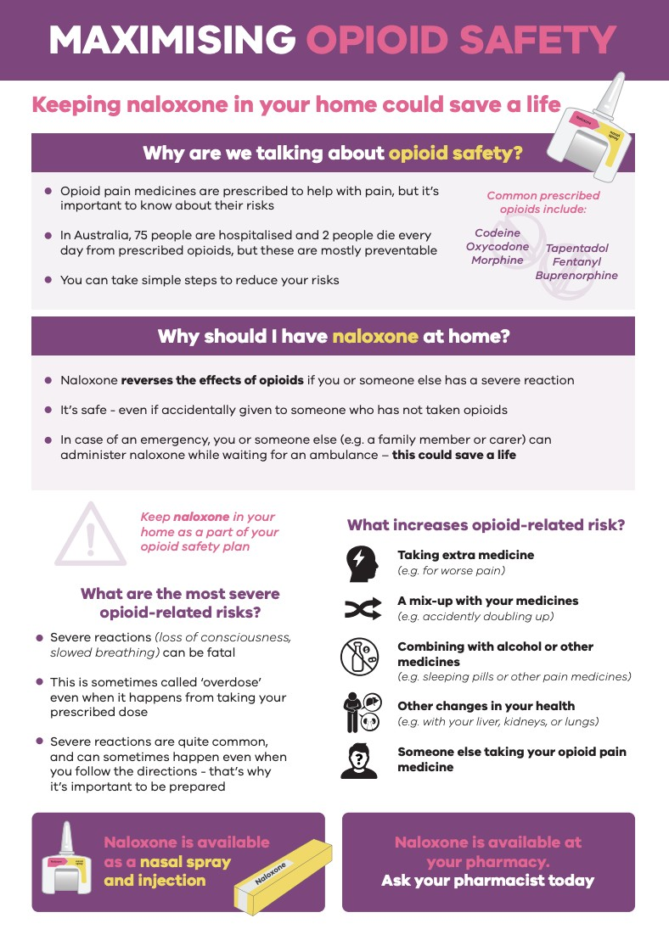

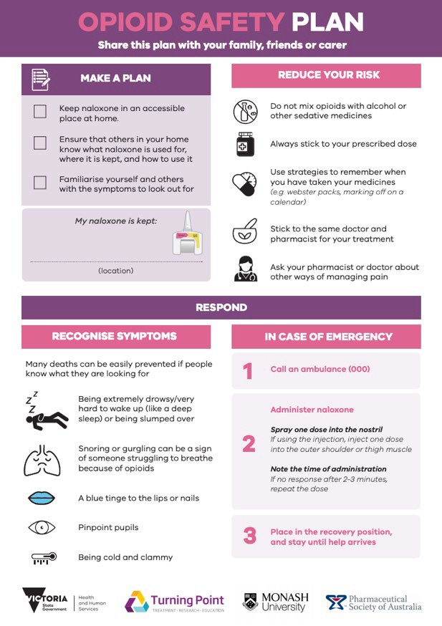

Appendix 4: Pharmacist training animation: illustration example



35

